School Financial Benchmarking Comparisons for 2023-24 Budget Planning
There are tools available to help you see how your school spends its money and the outcomes it achieves against other schools. As part of your 2023-24 budget planning, we would recommend that you review the Self-assessment Dashboard for your school(s) and use the benchmarking comparisons to investigate those areas where your school’s data on your dashboard suggests your school is significantly out of line with schools with similar characteristics.
The DfE changed the format for these reports last year, so we are unable to provide a spreadsheet with your dashboard alongside those for other schools in the Trust. However, we have downloaded both your dashboard for your 2021-22 budget and have prepared data for you to input to enable you to produce a second dashboard based on your 2022-23 Submitted budget. This is more straightforward than it sounds and will enable you to save a report with the dashboards side by side for direct comparison and ease of sharing with your governors responsible for finance. We have been unable to provide this additional information for schools joining the Trust during 2022-23.
We have also downloaded two sets of benchmarking charts for your school – one with the benchmark set of schools suggested by the tool based on academies with similar characteristics, and another with schools of a similar size within the Trust. These are available for you in Foldr for you to review, use for reporting and share with your governors. The dashboards for 2021-22 will be shared with Finance Trustees.

Self-assessment Dashboard
The Self-assessment Dashboard helps to provide Trust and Local Governing Boards with assurance that they are meeting the basic standards necessary to achieve a good level of financial health and resource management. The dashboard is useful to see how a school’s data compares to thresholds on a range of statistics that have been identified by the DfE as indicators for good resource management and outcomes. It can be used to identify possible areas for change to ensure that resources are being used to support high-quality teaching and the best education outcomes for pupils.
As part of the information provided for 2023-24 budget planning in Foldr, we have saved a copy of the DfE dashboard based on 2021-22 outturn data for your information. Additionally, to make use the most up to date data available, the Central Team have pulled together the raw data for you to produce a second custom dashboard based on your school’s 2022-23 submitted budget, rather than rely on other published data (excluding those schools who have recently joined the Trust). We have, as best as we can, tried to ensure that data has been completed on the same basis as the DfE thresholds to ensure that the data is rated meaningfully and as accurately as possible.
This data is available in Foldr. Add your school number (80XXXXX) to find your school’s data and complete the orange cells at the bottom of the spreadsheet (which are necessary to produce a custom dashboard. These should be completed in respect of in-year data (i.e. Oct 22 pupil census numbers and staffing data from the Employee Scenario used for your Submitted 2022-23 Budget). The other boxes as outlined below are not imperative but recommended.
All schools: Predicted percentage pupil number change in 3-5 years
On the raw data sheet:
Secondary schools: Teaching Periods in the timetable cycle
Total lessons taught by all teachers in the timetable cycle

Primary schools: Total number of classes

Once your data in the spreadsheet is complete, go to Schools Financial Benchmarking - GOV.UK (schools-financial-benchmarking.service.gov.uk)

Add your school name and click Start a Comparison

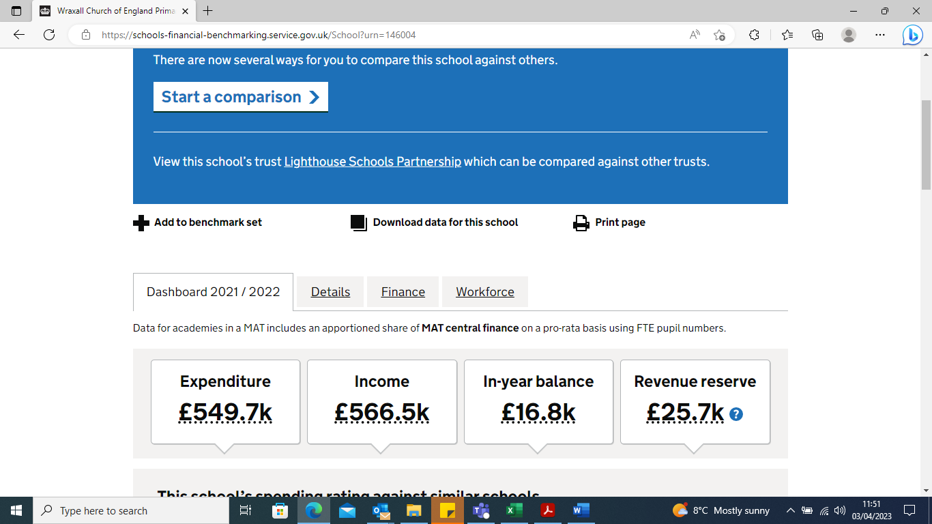

Choose Self-assessment dashboard and you will be directed to the Self-assessment dashboard for 2021-22 budget outturn.

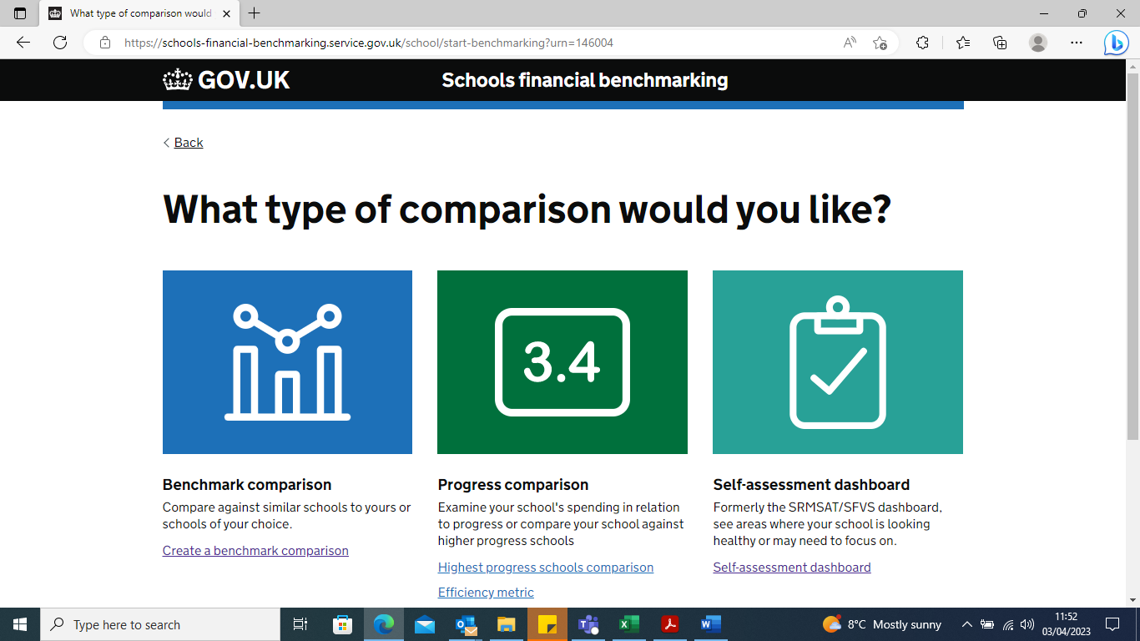

Click Add a Custom dashboard and name it 2022-23 Submitted Budget. Add the data from the spreadsheet provided.

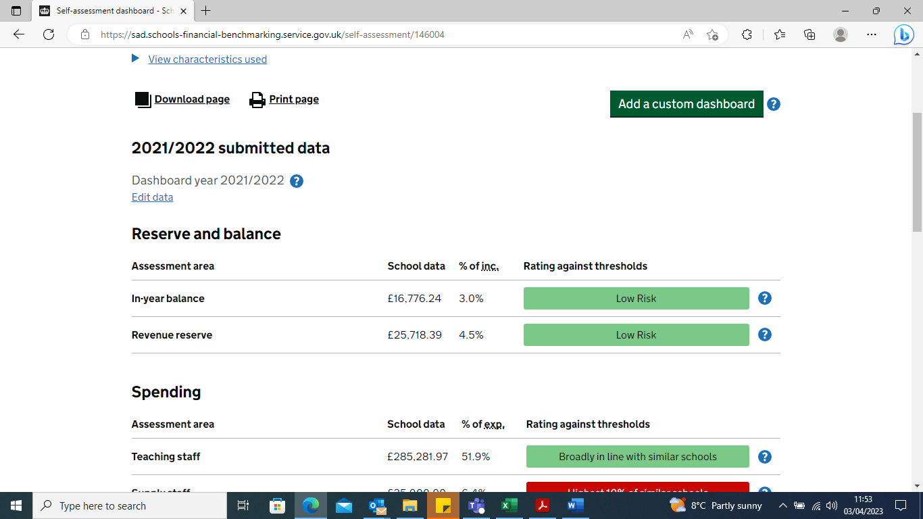

You will be able to download this report with both dashboards side by side for comparison if you wish.

Appendix 1 provides additional information to help schools interpret the dashboard.

Federated Schools
We are aware that some aspects of financial benchmarking do not work well for Federated Schools.
We have prepared a federated set of data that can be used to customise a dashboard for your 2022-23 Submitted Budgets, so you can produce a dashboard for review for your federated schools. This data can also be found in Foldr.
Use one of your schools to access the tool, add a custom dashboard for your federated data as outlined above for all schools and remove the 2021-22 dashboard before printing.

Benchmark Comparison

Use the Benchmark Comparison available from the same link Schools Financial Benchmarking - GOV.UK (schools-financial-benchmarking.service.gov.uk) or the charts we have provided for you in to investigate those areas highlighted on the dashboard as Red or Amber rated.
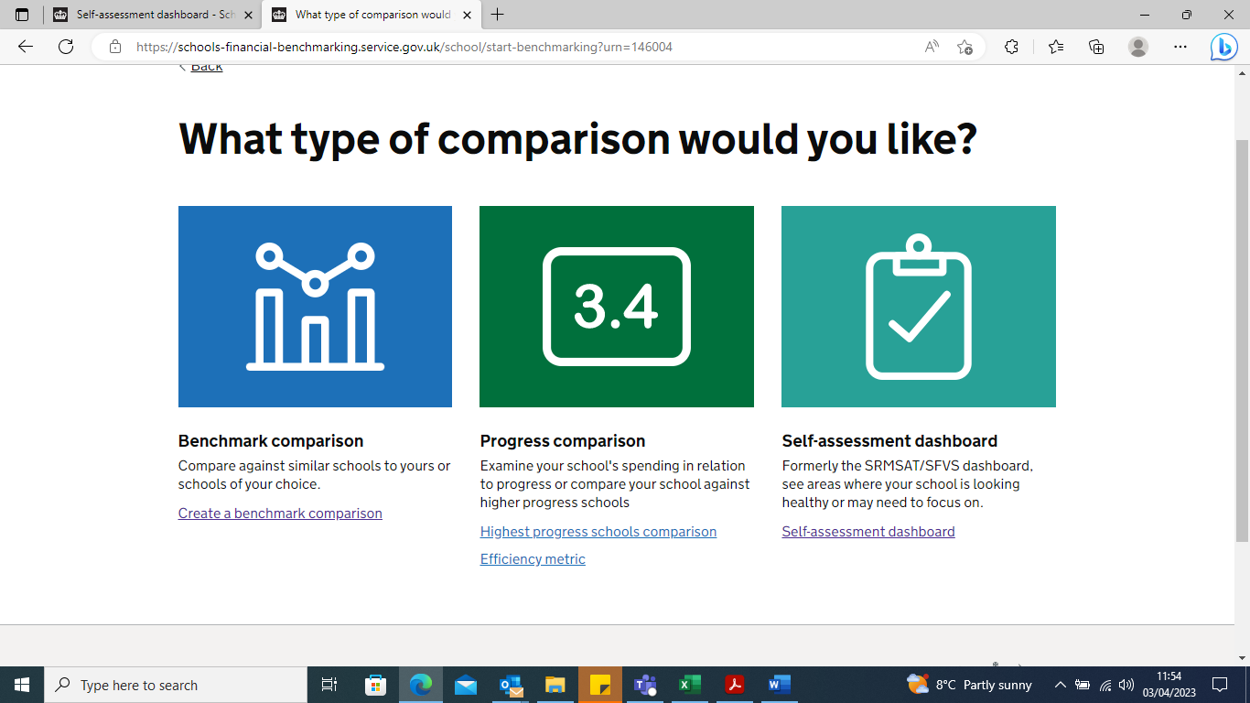

We used the quick comparison using pre-selected characteristics and academies to select the benchmark set. We used ‘Per pupil’ and ‘Excluded share of trust finance’ for all benchmarking charts.

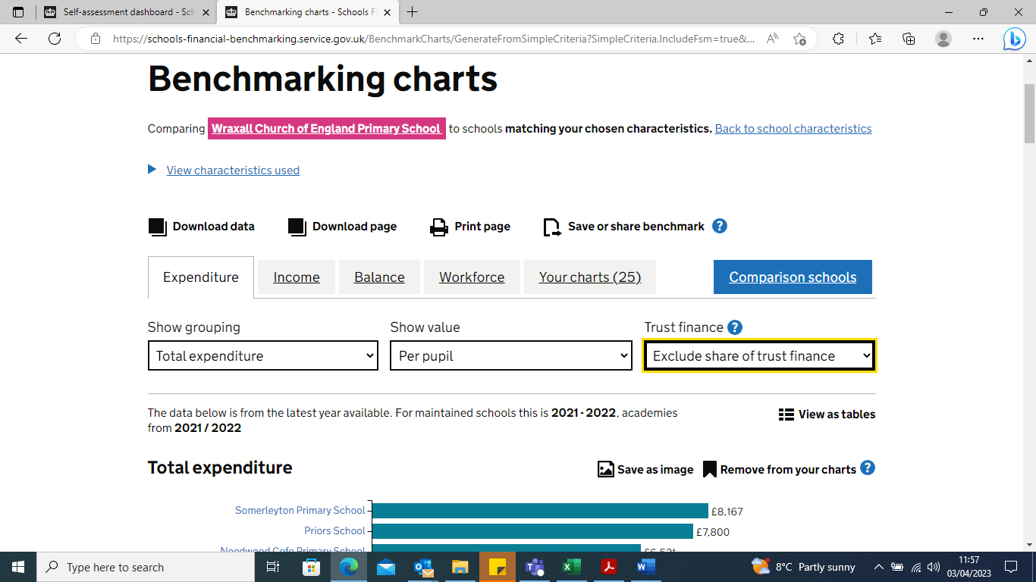

If you would prefer to produce your own benchmarking charts from the website, it may be easier for you to save the charts you wish to use as an image so you can add to another report with additional narrative.

We have also produced benchmarking charts for you to compare your school with similar sized schools within the Trust. We have downloaded these charts for each school and saved in Foldr but have also saved the links so that you can access them from the benchmarking site as well. You can find the links to the charts in Foldr.

Please tick ‘Replace benchmark set’ as shown below and then ‘Your charts’ before printing or downloading the charts.

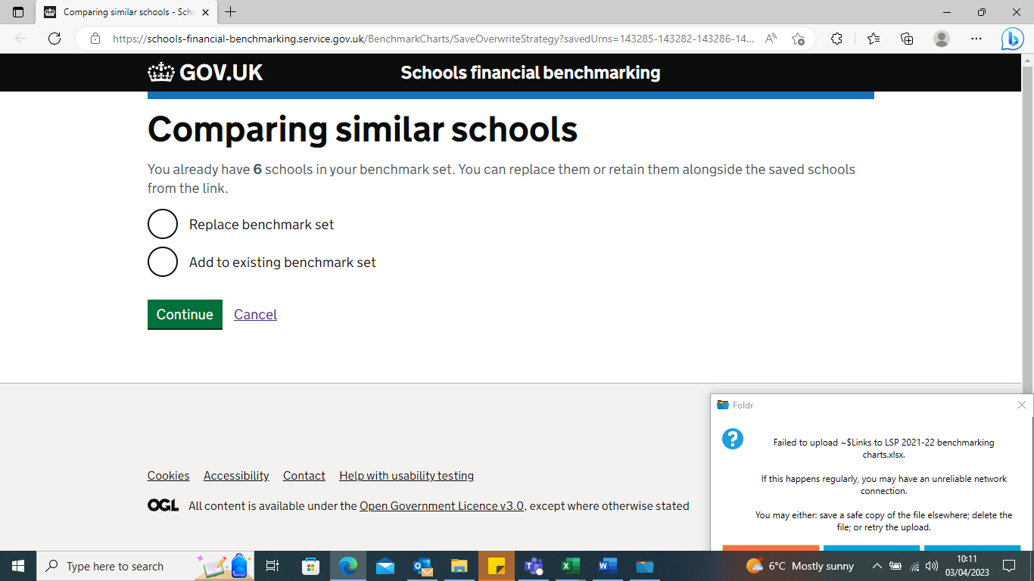

Appendix 1
Information to help schools interpret the dashboard
The table below shows schools which nominal codes have been included under each of the headings for the 2022-23 data.
School Resource Management Dashboard | CFR code -raw data | Orovia code | Nominal codes
Spend on teaching staff as a percentage of total expenditure | E1 | E1 | 2000 - Teachers - Salaries/Allowances
 |  |  | 2005 - Teachers - N.I.
 |  |  | 2010 - Teachers - Supn
 |  |  | 2015 - Teachers - Maternity
 |  |  | 2016 - Teachers - Sickness Premium
Spend on supply staff as a percentage of total expenditure | E2, E10 & E26 | E10 | 2100 - Supply - Salaries
 |  |  | 2105 - Supply - NI
 |  |  | 2110 - Supply - Supn
 |  | E26 | 2800 - Agency Supply Cover - Teaching
Spend on education support staff as a percentage of total expenditure | E3 | E3 | 2200 - Learning Support Assistants - Salaries
 |  |  | 2205 - Learning Support Assistants - NI
 |  |  | 2210 - Learning Support Assistants - Supn
 |  |  | 2215 - Learning Support Assistants - Overtime
 |  |  | 2250 - Foreign Language Assistants - Salaries
 |  |  | 2255 - Foreign Language Assistants - NI
 |  |  | 2260 - Foreign Language Assistants - Supn
 |  |  | 2265 - Foreign Language Assistants - Overtime
 |  |  | 2280 - Technicians - Salaries
 |  |  | 2285 - Technicians - NI
 |  |  | 2290 - Technicians - Supn
Spend on administrative and clerical staff as a percentage of total expenditure | E4 | E5 | 2515 - Invigilators - Overtime
 |  |  | 2600 - Exam Staff - Salaries
 |  |  | 2605 - Exam Staff - NI
 |  |  | 2610 - Exam Staff - Supn
 |  |  | 2615 - Exam Staff - Overtime
 |  |  | 2630 - Finance & Admin - Salaries
 |  |  | 2635 - Finance & Admin - NI
 |  |  | 2640 - Finance & Admin - Supn
 |  |  | 2645 - Finance & Admin - Overtime
 |  |  | 2650 - Librarian - Salaries
 |  |  | 2655 - Librarian - NI
 |  |  | 2660 - Librarian - Supn
 |  |  | 2720 - Cover Assistants - Salaries
 |  |  | 2725 - Cover Assistants - NI
 |  |  | 2730 - Cover Assistants - Supn
Spend on other staff costs as a percentage of total expenditure | E7, E8, E9,& E11 | E5 | 2820 - Out of hours staff - Salaries
 |  |  | 2825 - Out of hours staff - NI
 |  |  | 2830 - Out of hours staff - Supn
 |  |  | 2835 - Out of hours staff - Overtime
 |  |  | 6030 - Child Care Voucher Admin
 |  | E7 | 2320 - Lettings - Salaries
 |  |  | 2700 - Lunchtime supervisor - Salaries
 |  |  | 2705 - Lunchtime Supervisor - NI
 |  |  | 2710 - Lunchtime Supervisor - Supn
 |  |  | 2715 - Lunchtime Supervisor - Overtime
 |  | E8 | 2840 - LGPS pension deficit
 |  |  | 2900 - Apprenticeship Levy
 |  |  | 6005 - Apprenticeship Levy
 |  |  | 6010 - Recruitment Costs - inc interview exps
 |  |  | 6015 - Staff Travel
 |  |  | 6020 - CRB Checks
 |  |  | 6025 - Hospitality
 |  | E9 | 6000 - Training Costs
 |  | E23 | 3265 - Absence and Maternity Insurance Costs
Spend on premises (including staff costs) as a percentage of total expenditure | E5, E13, E14, E18, & E36 | E4 | 2300 - Premises Staff - Salaries
 |  |  | 2305 - Premises Staff - NI
 |  |  | 2310 - Premises Staff - Supn
 |  |  | 2315 - Premises Staff - Overtime
 |  | E12 | 3000 - Building Projects / Maintenance > £1K
 |  |  | 3005 - Repairs & Maintenance (below £1,000)
 |  |  | 3012 - Premises Compliance contracts
 |  | E13 | 3010 - Grounds Maintenance - Contract
 |  |  | 3011 - Grounds Maintenance - Non - contract
 |  | E14 | 3105 - Cleaning Contract
 |  |  | 3110 - Cleaning Materials
 |  |  | 3120 - Hygiene Services
 |  | E30 | 7900 - Revenue Contribution to Capital
Spend on teaching resources as a percentage of total expenditure | E22, E23, & E24 | E19 | 4000 - Student Rewards
 |  |  | 4001 - Educational Resources
 |  |  | 4002 - Home to school transport
 |  |  | 4003 - Pupil - House hardship
 |  |  | 4004 - Reprographics - Educational
 |  |  | 4005 - Books
 |  |  | 4006 - Swimming Pool Charges
 |  |  | 4010 - Equipment (Not IT - below £1,000)
 |  |  | 4011 - Equipment (Not IT - over £1,000)
 |  |  | 4020 - Stationery
 |  |  | 4025 - Photocopying
 |  |  | 4035 - Educational Visits Subsidy - Cost Centre
 |  |  | 4036 - Educational Visits Subsidy - Trip
 |  |  | 4040 - Student Bursary Payment 16-19
 |  |  | 4041 - Student Bursary Pupil Premium
 |  |  | 4042 - Teaching sch-Charges from other Schools
 |  |  | 4043 - Student Course Fees
 |  |  | 4135 - Professional Services - Educational
 |  |  | 4140 - Subscriptions
 |  |  | 6500 - Trips Travel Costs
 |  |  | 6505 - Trips Accomodation/Entrance
 |  |  | 6525 - Trips Music Tuition
 |  |  | 6540 - Trips parentpay fees
 |  | E20 | 4015 - IT Consumables - Educational
 |  |  | 4155 - IT Equipment - Educational
 |  |  | 4160 - Reprographic - Leases (Faculty)
 |  |  | 4170 - Work Experience
 |  | E21 | 4145 - Examination Invigilation
 |  |  | 4150 - Examination Fees
Spend on energy as a percentage of total expenditure | E16 | E16 | 3205 - Gas
 |  |  | 3210 - Electricity
 |  |  | 3215 - Oil
 |  |  | 3220 - Rent
Other spending as a percentage of total expenditure (balancing line) | E6, E15, E17, E19, E21, E25, E28, E29, E30, E31, E32, E33 & E35 | E6 | 2850 - Salaries - Catering Staff
 |  |  | 2855 - Salaries - Catering Staff NI
 |  |  | 2860 - Salaries - Catering Staff - SUPN
 |  | E15 | 3200 - Water/Sewerage Charges
 |  | E17 | 3250 - Rates
 |  | E18 | 3100 - Caretaker Supplies
 |  |  | 3125 - Refuse Disposal
 |  |  | 3300 - Fire Alarm & Extinguishers
 |  |  | 3305 - Security
 |  |  | 3320 - PAT Testing
 |  |  | 3330 - Health and Safety
 |  |  | 3340 - Lettings Related Expenditure
 |  |  | 3341 - VATpartial exemption add back
 |  |  | 5145 - General Office Costs
 |  | E22 | 5100 - Catering Contract
 |  |  | 5105 - Mobile Phones
 |  |  | 5106 - Telephones (incs mobiles)
 |  |  | 5107 - Internet Charges
 |  |  | 5110 - Advertising
 |  |  | 5115 - Postage
 |  |  | 5120 - Photocopying / Printing - Admin
 |  |  | 5121 - Leases - Non Educational
 |  |  | 5125 - Subscriptions - Admin
 |  |  | 5130 - Stationery - Admin
 |  |  | 5135 - IT Support Services
 |  |  | 5155 - Bank Charges
 |  |  | 5156 - Parentpay fees
 |  |  | 5200 - Furniture/Equipment
 |  |  | 5300 - IT Equipment - Non-Educational
 |  |  | 5305 - IT Consumables - Non-Educational
 |  |  | 5310 - IT Licensing
 |  |  | 5400 - Out of hours clubs food
 |  |  | 5403 - Out of hours clubs - Parentpay fees
 |  | E23 | 3260 - Insurance
 |  |  | 5402 - Out of hours clubs resources
 |  | E25 | 4007 - Pupil paid meals
 |  |  | 4008 - Pupil FSM (UIFSM & KS2)
 |  |  | 4009 - Adult meals
 |  |  | 5000 - Catering Food/Drink
 |  |  | 5005 - Catering Maintenance & Repairs
 |  |  | 5010 - Catering Equipment
 |  |  | 5015 - Catering Consumables
 |  | E27 | 2805 - Agency Supply Cover - Support
 |  |  | 5140 - Professional Services - Non Educational
 |  |  | 5150 - Accountancy Services - Non Audit
 |  |  | 5151 - Audit Costs
 |  |  | 5160 - Music Services Costs
 |  |  | 5165 - Head Office Recharge
 |  |  | 5166 - Head Office Expense - recharged services

The guidance below provides a detailed explanation to help schools understand how data is added/calculated and how you can use the results from the dashboard.
Using the results from the dashboard
The dashboard provides red, amber or green (RAG) ratings against a school’s data that indicates how its spend and characteristics compare with similar schools or nationally recognised bandings and recommendations:
- a red rating shows the school’s data is significantly out of line with schools with similar characteristics or recognised characteristics. It does not mean that there is definitely a problem, but that there may be scope for change
- an amber rating shows that the school’s data is considerably out of line with the majority of similar schools or recognised characteristics
- a light green rating shows that the school’s data is in line with the majority of other schools or recognised standards - it does not necessarily mean that there is no scope for change
- a dark green rating shows that the school’s data is close to the middle of similar schools or better than recognised standards. Not all indicators will generate a dark green rating
The school should carefully consider the results for each indicator. For example:
- why might the rating against the threshold be as it is?
- if the school is an outlier, are there any follow-up actions – for example, further investigation or changes to be made?
- if so, the schools financial benchmarking service or school performance service can be used to identify schools to contact and learn from.

A. Information about your school
The first section of the dashboard requires the school to input the:
- name of the school
- school’s phase (from a drop-down list)
- region in which the school is based (from a drop-down list)
- number of pupils in the school
- percentage of pupils eligible for free school meals (FSM) in the current year
- year you are entering data for (from a drop-down list)
This information is used to ensure the school is being compared with similar schools, for example those in the same phase and with a similar number of pupils and FSM rates.

B. Your spending as a percentage of total expenditure

Spend on teaching staff as a percentage of total expenditure
Spend on teaching staff typically takes up the largest proportion of a school’s overall spending.
Schools may receive an amber or red rating on this indicator if they spend significantly less or more of their budget on teaching staff than other schools.
Schools should understand their rating and whether any changes are required to achieve better resource management.

Calculating your data
Spend on teaching staff as a percentage of total expenditure = (spend on teaching staff [E1] ÷ total expenditure) × 100%
Spend on teaching staff includes the salaries and wages (including allowances, maternity pay, employer’s contributions to National Insurance, and teacher’s pensions) of permanent teaching staff.
It excludes teachers employed casually and directly. For example supply teachers, and any teacher not employed directly by the school, such as agency staff.
Thresholds for this indicator are determined by comparing spend among similar schools.
Percentage | RAG rating
Upper and lower 10% of schools | Red
Upper and lower 10% to 20% of schools | Amber
Middle 20% of schools | Dark green
All other schools | Light green

Spend on supply staff as a percentage of total expenditure
Schools may receive an amber or red rating on this indicator if they spend significantly more of their budget on supply staff than other schools.
Schools should understand their rating and whether any changes are required to achieve better resource management.

Calculating your data
Spend on supply staff as a percentage of total expenditure = (spend on (supply staff [E2] + supply teacher insurance [E10] + agency supply teaching staff [E26] ) ÷ total expenditure) × 100%
Spend on supply staff includes salaries and wages (including allowances, maternity pay, employer contributions to National Insurance, and teachers’ pensions) for supply teaching staff employed to cover teaching staff absence.
It includes supply teachers that are employed directly by the school and those that are paid through an agency or third party.
It also includes premiums paid to insurers for supply teacher cover and sums de-delegated by the local authority for centrally managed schemes for supply cover.
Thresholds for this indicator are determined by comparing spend among similar schools.
Percentage | RAG rating
Upper and lower 10% of schools | Red
Upper and lower 10% to 20% of schools | Amber
Middle 20% of schools | Dark green
All other schools | Light green

Spend on education support staff as a percentage of total expenditure
Spend on education support staff typically takes up the second largest proportion of a school’s overall spending.
Schools may receive an amber or red rating on this indicator if they spend significantly more of their budget on education support staff than other schools. Schools should understand their rating and whether any changes are required to achieve better resource management.

Calculating your data
Spend on education support staff as a percentage of total expenditure = (spend on education support staff [E3] ÷ total expenditure) × 100%
Spend on education support staff includes salaries and wages (including allowances, maternity pay, employer’s contributions to National Insurance and pensions) for permanent support staff employed directly by the school in support of pupils’ education.
It excludes education support staff that are not employed directly by the school and costs that are incurred as part of a service contract.
Thresholds for this indicator are determined by comparing spend among similar schools.
Percentage | RAG rating
Upper and lower 10% of schools | Red
Upper and lower 10% to 20% of schools | Amber
Middle 20% of schools | Dark green
All other schools | Light green

Spend on administrative and clerical staff as a percentage of total expenditure
Schools may receive an amber or red rating on this indicator if they spend significantly more of their budget on administrative and clerical staff than other schools. Schools should understand their rating and whether any changes are required to achieve better resource management.

Calculating your data
Spend on administrative and clerical staff as a percentage of total expenditure = (spend on administrative and clerical staff [E4] ÷ total expenditure) × 100%
Spend on administrative and clerical staff includes salaries and wages (including allowances, maternity pay, employer’s contributions to National Insurance and pensions) for administrative and clerical staff employed directly by the school. This includes:
- business managers and bursars
- clerk to the governing body
- receptionists
- school secretaries
- other administrative staff
- telephonists
- typists
- IT managers
It excludes administrative and clerical staff that are not employed directly by the school and costs that are incurred as part of a service contract.
It also excludes IT teachers and staff employed to manage and support the school’s special facilities.
Thresholds for this indicator are determined by comparing spend among similar schools.
Percentage | RAG rating
Upper and lower 10% of schools | Red
Upper and lower 10% to 20% of schools | Amber
All other schools | Light green

Spend on other staff costs as a percentage of total expenditure
Schools may receive an amber or red rating on this indicator if they spend significantly more of their budget on other staff costs than other schools.
Schools should understand their rating and whether any changes are required to achieve better resource management.

Calculating your data
Spend on other staff costs as a percentage of total expenditure = (spend on (other staff costs [E7] + indirect employee expenses [E8] + staff development and training [E9] + staff-related insurance [E11] ) ÷ total expenditure) × 100%
Spend on other staff costs includes salaries and wages (including allowances, maternity pay, employer’s contributions to National Insurance and pensions) for other staff employed directly by the school.
It also includes indirect employee expenses (excluding salary costs), staff development and training (excluding the cost of supply staff used to cover teacher absence), and staff-related insurance (excluding insurance for supply teachers; premises related insurance; vehicle insurance; and school trip insurance).
Thresholds for this indicator are determined by comparing spend among similar schools.
Percentage | RAG rating
Upper and lower 10% of schools | Red
Upper and lower 10% to 20% of schools | Amber
All other schools | Light green

Spend on premises (including staff) costs as a percentage of total expenditure
Schools may receive an amber or red rating on this indicator if they spend significantly more of their budget on premises costs than other schools.
Schools should understand their rating and whether any changes are required to achieve better resource management.

Calculating your data
Spend on premises costs as a percentage of total expenditure = (spend on (premises staff [E5] + maintenance of premises [E13] + cleaning and caretaking [E14] + grounds maintenance [E18] + PFI charges [E36] ) ÷ total expenditure) × 100%
Spend on premises includes salaries and wages (including allowances, maternity pay, employer’s contributions to National Insurance and pensions) for premises staff employed directly by the school. This includes:
- caretakers
- cleaners
- grounds staff
- maintenance staff
- porters
- messengers
- security staff
It also includes costs associated with building and grounds maintenance, improvement and cleaning and caretaking, and PFI costs.
Thresholds for this indicator are determined by comparing spend among similar schools with:
Percentage | RAG rating
Upper and lower 10% of schools | Red
Upper and lower 10% to 20% of schools | Amber
All other schools | Light green

Spend on teaching resources as a percentage of total expenditure
Schools may receive an amber or red rating on this indicator if they spend significantly less of their budget on teaching resources than other schools.
Schools should understand their rating and whether any changes are required to achieve better resource management.

Calculating your data
Spend on teaching resources as a percentage of total expenditure = (spend on (teaching resources [E22] + ICT teaching resources [E23] + examination fees [E24] ) ÷ total expenditure) × 100%
Spend on teaching resources includes curriculum ICT costs and the cost of test and examination fees and any accreditation costs related to pupils.
The latter includes GCSEs and A/AS levels. Primary schools are unlikely to have any costs associated with examination fees.
Thresholds for this indicator are determined by comparing spend among similar schools.
Percentage | RAG rating
Upper 10% | Red
Upper 10% to 20% | Amber
Middle 20% | Dark green
All other schools | Light green

Spend on energy as a percentage of total expenditure
Schools may receive an amber or red rating on this indicator if they spend significantly more of their budget on energy than other schools.
Schools should understand their rating and whether any changes are required to achieve better resource management.
Spend that is significantly higher than other schools may suggest that too much resource is spent on energy and more conservation may need to be considered for both environmental and expense reasons.
Deals for schools provides information on a wide range of non-staff deals that have been reviewed by the Schools Commercial Team (SCT) in DfE.
These are assessed for compliance with procurement regulations, ease of use, suitability and value for money.
Many schools have made significant changes by changing their suppliers to those recommended by DfE.

Calculating your data
Spend on energy as a percentage of total expenditure = (spend on energy [E16] ÷ total expenditure) × 100%
Spend on energy includes all costs related to fuel and energy.
It excludes any costs arising from repairs or maintenance to energy supplies.
Thresholds for this indicator are determined by comparing spend among similar schools.
Percentage | RAG rating
Upper and lower 10% of schools | Red
Upper and lower 10% to 20% of schools | Amber
All other schools | Light green

Other spending as a percentage of total expenditure
This is a balancing line to ensure that the total spending section totals 100%. It is not rated against thresholds.

Calculating your data
Other spending as a percentage of total expenditure = (spend on (catering staff [E6] + water and sewerage [E15] + rent and rates [E17] + other occupation costs [E19] + special facilities [E21] + educational consultancy [E25] + catering supplies [E28] + auditor costs [E29] + other insurance premiums [E30] + administrative supplies [E31] + direct revenue finance [E32] + professional services [E33] + interest charges for loan and bank [E35]) ÷ total expenditure) × 100%

C. Reserves / balances as a percentage of total income

In-year balance as a percentage of total income
Schools should set a well-informed and balanced budget that does not lead to an excessive surplus or deficit at the end of the year.
Schools may spend more than their income in a given year for a range of planned and sensible reasons, but it may also be a sign the school is not effectively managing its budget.
Schools will receive an amber or red rating on this indicator if their total spending is more than their income in a given year.

Calculating your data
In-year balance as a percentage of total income = ((total income - total expenditure) ÷ total income) × 100%
An in-year deficit is indicated by a negative result, and an in-year surplus is indicated by a positive result.
Ratings are:
Percentage | RAG rating
Schools with an in-year deficit of over 5% | Red
Schools with an in-year deficit of less than 5% | Amber
Schools with a balanced budget or an in-year surplus | Light green

Revenue reserve as a percentage of total income
Schools will receive an amber or red rating on this indicator if their total revenue reserves are negative. Any schools running a deficit should have a plan to eliminate the deficit.

Calculating your data
Revenue reserve as a percentage of total income = ((Restricted and unrestricted funds carried forward from the previous year + total income from current year – total expenditure in current year) ÷ total income in current year) × 100%
A cumulative deficit / negative reserve is indicated by a negative result, and a cumulative surplus / positive reserve is indicated by a positive result.
Ratings are:
Percentage | RAG rating
Schools with negative revenue reserves of over 5% | Red
Schools with negative revenue reserves of less than 5% | Amber
Schools with no revenue reserves or a positive balance | Light green

D. School characteristics

Average teacher cost
Spend on teaching staff typically takes up the largest proportion of a school’s overall spending.
Key factors determining the level of spend on teaching staff include the number of teachers; the structure of the school workforce; and the average teacher cost.
Schools may receive an amber or red rating on this indicator if their average teacher cost is significantly lower or higher than other schools.
Schools should understand their rating and whether any changes are required to achieve better resource management.
An average teacher cost that is significantly different from other schools may suggest that the staffing grade profile; the responsibility structure of the school; or the pay flexibilities (for example differentiating pay by teachers’ performance) are different from other schools and may be a consideration for change.

Calculating your data
Average teacher cost = spend on teaching staff [E1] ÷ full time equivalent number of teachers
Spend on teaching staff includes the salaries and wages (including allowances, maternity pay, employer’s contributions to National Insurance, and teachers’ pensions) of permanent teaching staff.
It excludes teachers employed casually and directly, such as supply teachers, and any teacher not employed directly by the school such as agency staff.
Full time equivalent number of teachers includes both classroom teachers and teachers in the leadership group. It excludes teaching assistants, non-classroom based school support staff, and auxiliary staff.
For schools in inner or outer London, thresholds for this indicator are determined by comparing average teacher cost amongst other schools in London.
For schools outside London, thresholds for this indicator are determined by comparing average teacher cost amongst other schools outside London.
Percentage | RAG rating
Upper and lower 10% of schools | Red
Upper and lower 10% to 20% of schools | Amber
Middle 20% of schools | Dark green
All other schools | Light green

Senior leaders as a percentage of workforce
Schools have different senior leadership teams and structures.
Schools may receive an amber or red rating on this indicator if senior leaders as a percentage of workforce is significantly higher than other schools.
Schools should understand their rating and whether any changes are required to achieve better resource management.
Having a high proportion of the workforce in the leadership group may suggest that not enough of the workforce is focused on teaching.

Calculating your data
Senior leaders as a percentage of workforce = full time equivalent number of teachers in the leadership group ÷ full time equivalent total school workforce
Full time-equivalent number of teachers in the leadership group includes headteachers, deputy headteacher, and assistant headteachers.
Thresholds for this indicator are determined by comparing spend among similar schools.
Percentage | RAG rating
Upper and lower 10% of schools | Red
Upper and lower 10% to 20% of schools | Amber
Middle 20% of schools | Dark green
All other schools | Light green

Pupil to teacher ratio
The pupil to teacher ratio indicates how many pupils there are to each teacher across the whole school.
Schools may receive an amber or red rating on this indicator if their pupil to teacher ratio is significantly lower or higher than other schools.
Schools should understand their rating and whether any changes are required to achieve better resource management.
A relatively low pupil to teacher ratio may suggest that class sizes are small which may be costly and not the best use of resources. A relatively high pupil to teacher ratio may affect pupil outcomes and teacher workload.

Calculating your data
Pupil to teacher ratio = total number of pupils ÷ full time equivalent number of teachers
Full time equivalent number of teachers includes both classroom teachers and teachers in the leadership group. It excludes teaching assistants, non-classroom based school support staff, and auxiliary staff.
Thresholds for this indicator are determined by comparing spend among similar schools.
Percentage | RAG rating
Upper and lower 10% of schools | Red
Upper and lower 10% to 20% of schools | Amber
Middle 20% of schools | Dark green
All other schools | Light green

Pupil to adult ratio
The pupil to adult ratio indicates how many pupils there are to each member of staff across the whole school.
Schools may receive an amber or red rating on this indicator if their pupil to adult ratio is significantly lower or higher than other schools.
Schools should understand their rating and whether any changes are required to achieve better resource management.
A relatively low pupil to adult ratio may suggest that there are too many members of staff for the number of pupils which may not be a suitable use of resource.
A relatively high pupil to adult ratio may affect pupil outcomes and staff workload.
A high pupil to teacher ratio but a low pupil to adult ratio may suggest that the school’s workforce could be weighted too greatly towards non-teaching staff.

Calculating your data
Pupil to adult ratio = total number of pupils ÷ full time equivalent total school workforce
Thresholds for this indicator are determined by comparing spend among similar schools .
Percentage | RAG rating
Upper and lower 10% of schools | Red
Upper and lower 10% to 20% of schools | Amber
Middle 20% of schools | Dark green
All other schools | Light green

Teacher contact ratio
All teachers should have a guaranteed minimum of 10% timetabled planning, preparation and assessment (PPA) time.
The Association of School and College Leaders (ASCL) advocates 0.78 as an aspirational target for average contact ratio, on the basis that this represents approximately 10% of all timetabled teacher time in planning and preparation, 10% in management activity, and 2% margin. But schools should make their own decisions on average contact ratio to reflect their own circumstances and affordability
Schools will receive an amber or red rating on this indicator if their teacher contact ratio is significantly lower or higher than the ASCL aspirational target.
Schools should understand their rating and whether any changes are required to achieve better resource management.
An average teacher contact ratio significantly higher than 0.78 could indicate that not enough time is given to PPA and management activity.
An average teacher contact ratio significantly lower than 0.78 might indicate flexibility to increase available teaching time in the classroom.
When deciding how much of their staff’s time is spent on PPA and management activity, schools should always consider:
- their individual context and circumstances
- the demands being placed on their staff
- what can be reasonably expected in terms of teaching load
- the cost and affordability of the resulting teacher contact ratio

Calculating your data
For secondary schools:
Teacher contact ratio = total number of teaching periods timetabled for all teachers in the school ÷ total possible number of teaching periods
The total possible number of teaching periods is equivalent to the number of teaching periods in the timetable cycle multiplied by the full time equivalent number of teachers.
Full time equivalent number of teachers includes both classroom teachers and teachers in the leadership group. It excludes teaching assistants, non-classroom based school support staff, and auxiliary staff.
For primary schools:
Teacher contact ratio = total number of classes ÷ full time equivalent number of teachers
Full time equivalent number of teachers includes both classroom teachers and teachers in the leadership group. It excludes teaching assistants, non-classroom based school support staff, and auxiliary staff.
The teacher contact ratio will always be less than 1.0.
Thresholds for this indicator are set on the basis of ASCL’s aspirational target of 0.78.
Percentage | RAG rating
Schools with an average teacher contact ratio of over 0.82 or below 0.70 | Red
Schools with an average teacher contact ratio of between 0.80 and 0.82 or between 0.70 and 0.74 | Amber
Schools with an average teacher contact ratio of between 0.74 and 0.80 | Light green

Predicted percentage pupil number change in 3 to 5 years
Schools should be making 3 to 5 year financial projections and assumptions. A key factor determining a school’s finances is pupil numbers.
Schools will receive an amber or red rating on this indicator if they are predicting a significant decrease in pupil numbers over that period.
Predicting a significant reduction in pupil numbers over this period risks implying that the school may not be financially sustainable in the medium term.
The school should consider how medium-term budgets may be affected by the pupil projections and what could be put in place now to mitigate risks and ensure it has the necessary funding in the future.
Schools predicting a reduction in pupil numbers of more than 10% receive a red rating; schools predicting a reduction in pupil numbers of between 2% and 10% receive an amber rating; and all others receive a light green rating.

Average class size
Average class sizes are a key determinant of the cost of running a school.
Schools will receive an amber or red rating on this indicator if their average class size is significantly lower or higher than other schools.
Schools should understand their rating and whether any changes are required to achieve better resource management.
A relatively low average class size could imply that the per-pupil funding does not cover the cost of delivering the class and may not be an effective use of resources.
A relatively large average class size may affect pupil outcomes and teacher workload, and may contribute to higher costs in other areas of the budget.
Thresholds for this indicator are determined by comparing the average size of a one-teacher class amongst similar schools.
Percentage | RAG rating
Upper and lower 10% of schools | Red
Upper and lower 10% to 20% of schools | Amber
Middle 20% of schools | Dark green
All other schools | Light green

E. Outcomes

Ofsted rating
Schools should select their most recent Ofsted rating from the drop down list.
Schools rated Inadequate receive a red rating; schools rated Requires Improvement receive an amber rating; schools rated Good receive a light green rating; and schools rated Outstanding receive a dark green rating.

Progress 8 score
Progress 8 scores show how much progress pupils have made between the end of key stage 2 and the end of key stage 4, compared to pupils across all of England who got similar results at the end of key stage 2. This measure only applies to schools with key stage 4.
Schools will receive an amber or red rating if their progress score is below average.

Calculating your data
Progress scores can be found on the school performance tables website.
Thresholds have been set using the department’s progress measure bandings.
Percentage | RAG rating
Progress 8 score of -0.5 or lower | Red
Progress 8 score of between -0.5 and 0 | Amber
Progress 8 score of between 0 and 0.5 | Light green
Progress 8 score of greater than 0.5 | Dark green

Progress scores in reading, writing and maths
Progress scores for reading, writing and maths show how much progress pupils have made between the end of key stage 1 and the end of key stage 2, compared to pupils across all of England who achieved similar results at the end of key stage 1. This measure only applies to schools with key stage 2 classes.
Schools will receive an amber or red rating if their progress score is below average.

Calculating your data
Progress scores can be found on the school performance tables website.
Thresholds have been set using the department’s progress measure bandings.

Reading
Percentage | RAG rating
Schools with a progress score of less than -2.7 | Red
Schools with a progress score of between -2.7 and 0 | Amber
Schools with a progress score of between 0 and 3.2 | Light green
Schools with a progress score of greater than 3.2 | Dark green

Writing
Percentage | RAG rating
Schools with a progress score of less than -2.6 | Red
Schools with a progress score of between -2.6 and 0 | Amber
Schools with a progress score of between 0 and 2.7 | Light green
Schools with a progress score of greater than 2.7 | Dark green

Maths
Percentage | RAG rating
Schools with a progress score of less than -3.1 | Red
Schools with a progress score of between -3.1 and 0 | Amber
Schools with a progress score of between 0 and 3.2 | Light green
Schools with a progress score of greater than 3.2 | Dark green

Technical explanation
Using the latest available data on schools and academies spend and characteristics, we have calculated thresholds for:
- section B (spending as a percentage of total expenditure)
- senior leaders as a percentage of workforce
- pupil to teacher ratio
- pupil to adult ratio
- average class size
For each of these indicators, schools are put into one of the following categories:
- very small primary schools with low free school meals (FSM) rates
- very small primary schools with medium FSM rates
- very small primary schools with high FSM rates
- small primary schools with low FSM rates
- small primary schools with medium FSM rates
- small primary schools with high FSM rates
- medium primary schools with low FSM rates
- medium primary schools with medium FSM rates
- medium primary schools with high FSM rates
- large primary schools with low FSM rates
- large primary schools with medium FSM rates
- large primary schools with high FSM rates
- small secondary schools with a sixth form and low FSM rates
- small secondary schools with a sixth form and medium FSM rates
- small secondary schools with a sixth form and high FSM rates
- medium secondary schools with a sixth form and low FSM rates
- medium secondary schools with a sixth form and medium FSM rates
- medium secondary schools with a sixth form and high FSM rates
- large secondary schools with a sixth form and low FSM rates
- large secondary schools with a sixth form and medium FSM rates
- large secondary schools with a sixth form and high FSM rates
- small secondary schools with no sixth form and low FSM rates
- small secondary schools with no sixth form and medium FSM rates
- small secondary schools with no sixth form and high FSM rates
- medium secondary schools with no sixth form and low FSM rates
- medium secondary schools with no sixth form and medium FSM rates
- medium secondary schools with no sixth form and high FSM rates
- large secondary schools with no sixth form and low FSM rates
- large secondary schools with no sixth form and medium FSM rates
- large secondary schools with no sixth form and high FSM rates
- all-through schools
- special schools
- alternative provision and PRUs
- nursery schools
We have explored including additional factors, including whether the school is rural or urban, and the percentage of pupils with special educational needs. These did not affect the resulting RAG ratings significantly, so we have left them out for simplicity. We will keep this under review as new data becomes available.
The definition of small, medium, and large schools is set using quartiles.
Primary schools
Number of pupils | Size of school
0 to 100 | Very small
101 to 175 | Small
176 to 385 | Medium
386 or more | Large
Secondary schools with a sixth form
Number of pupils | Size
0 to 770 | Small
771 to 1,300 | Medium
1,301 or more | Large
Secondary schools without a sixth form
Number of pupils | Size
0 to 485 | Small
486 to 935 | Medium
936 or more | Large
The definition of low, medium, and high FSM rates is also set using quartiles.
Primary schools
Percentage of pupils eligible for FSM | FSM rate
0% to 5% | Low
5% to 18% | Medium
Above 18% | High
Secondary schools with a sixth form
Percentage of pupils eligible for FSM | FSM rate
0% to 6% | Low
6% to 16.5% | Medium
Above 16.5% | High
Secondary schools without a sixth form
Percentage of pupils eligible for FSM | FSM rate
0% to 8% | Low
8% to 21.5% | Medium
Above 21.5% | High
To set the thresholds for average teacher costs, schools are categorised as:
- primary schools in inner or outer London
- primary schools outside London
- secondary schools with a sixth form in inner or outer London
- secondary schools with a sixth form outside London
- secondary schools with no sixth form in inner or outer London
- secondary schools with no sixth form outside London
- all-through schools in inner or outer London
- all-through schools outside London
- special schools in inner or outer London
- special schools outside London
- alternative provision and PRUs in inner or outer London
- alternative provision and PRUs outside London
- nursery schools in inner or outer London
- nursery schools outside London
The RAG ratings have been calculated using maintained school and academy 2017 to 2018 data. RAG ratings will be updated with 2018 to 2019 data later this year.
The majority of the metrics in the dashboard are percentages and ratios which at a national level don’t change significantly year on year, so they still provide a fair and useful comparison with your up to date data.
However, to reflect pay awards and pension contribution changes, the underlying data on teaching staff spending and average teacher costs have been adjusted. The RAG ratings for spend on teaching staff as a percentage of total expenditure and average teacher costs include uplifts relating to the year selected in the dashboard.
Teacher cost uplifts
Year | Uplift
2017 to 2018 | no uplift applied
2018 to 2019 | 2.4% uplift to reflect the September 2018 pay award
2019 to 2020 or later | 11.2% to reflect the September 2019 pay award and September 2019 pensions contribution changes

